NEWSLETTER
MAY 2017

The Coffee & Cake morning held on Thursday 16th February 2017 which included a tombola, raised £131.40 thanks to everyone who donated items and bought tickets.

Laken Reid, Cambria Martin’s mum had all her hair shaved off in aid of COG and raised a magnificent £1016.08 in the process. Thanks to all who sponsored her and we hope your head wasn’t too cold.

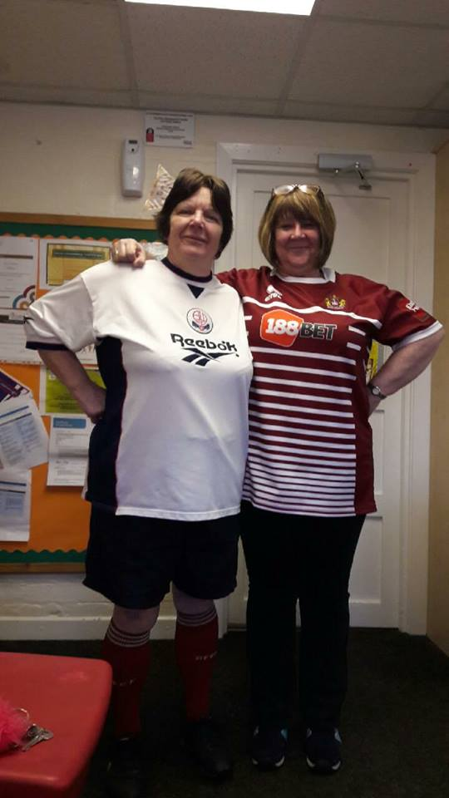
The fancy dress morning on Thursday 16th March, was a great success with many parents and most members of staff and children making an effort. Lots of Easter Eggs were donated as a result. On the left is a picture of Annette & Marian suitably attired.

Debra Richards, Louise’s mum did a sponsored walk and split the proceeds between COG and another organisation and we received £200. Thanks Debra.

In memory of C Twist £130.00
Egerton United reform Church £60
Jamie McMinn £120.00
In memory of Jeff Crook £740.
Giving a Bit £51.75

Easter Egg Bingo on Thursday 30th March 2017, from 7pm was attended by about 25 people. We had lots of easter Eggs, so many that we had enough for 10 games of bingo, playing for 1 line, 2 lines and a full house. It was a fun evening.
Thanks to all those who attended and we raised £141.60

ANNETTE DODD is undertaking a sponsored “WALK A MARATHON IN MAY”
A Marathon is 26m 385yd in length, which equates to 46,055 yd in total, which is a total of 1,657,980ins, which equates to 57,171.724 steps, which is an average of 1,844.25 steps per day. There is a sponsor form in the parent’s room or you can donate on line @
https://www.everyclick.com/annettesmaymarathon

JAMIE McMINN, James Holden’s mum is doing a sponsored Bungee Jump on the 21st of May in aid of COG. There is a sponsor form in the parent’s room. She was bought the bungee jump by a friend!!!??? Who needs enemies with a friend like that......LOL

Cheryl Wyatt & Elaine Nuttall will be holding a drop in session on Thursday 18th May 2017 from 9.30 to 11.30am. If you have any Education or Social Care queries they will be able to help. They are also looking for input from parents to help with the creation of a Pupil Passport

